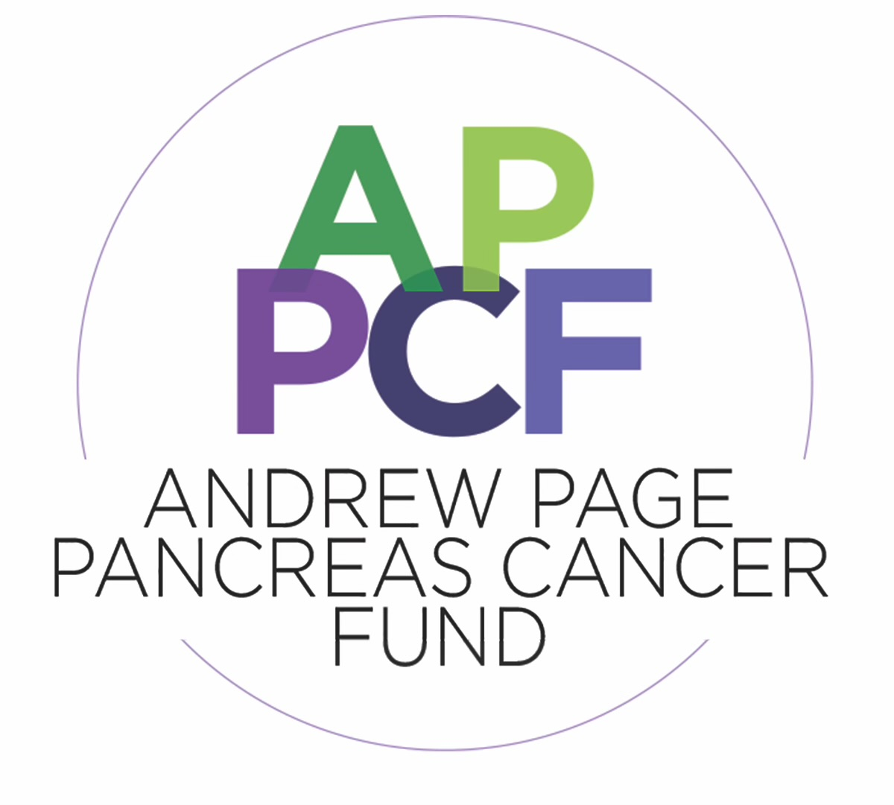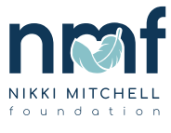

APP Intake Procedure and Script
Last updated 9/27/2022
• APP prescribes program following surgeon evaluation using the following script:
As part of your care-plan, we will enroll you in our virtual peer ambassador program, where you will meet current and former pancreas (surgery) patients and their care partners over Zoom weekly and work closely with our nurse navigator, physical therapist, and dietitian to help you prepare for your upcoming surgery. We prescribe this program to all our pancreas patients and our nurse navigator will join shortly to go over the program in more detail and answer any questions you might have.
Participants of the ambassador program have the option of receiving text message notifications to remind and to deliver video links. Message and data rates apply. If you wish to join the program but do not want to receive text messages, we can email you instead.
Do you authorize Nikki Mitchell Foundation to send you text messages?
- APP individualizes script based on diagnosis (i.e., tumor type) and/or treatment level (Thrive Together for neoadjuvant/adjuvant)
- APP answers questions and introduces team members
- APP handoff to RN navigator for remaining of onboarding process
- Associated materials: NLAP Rx Template, Program One-Pager

